Report on World Ostomy Awareness Day 2025

Theme: Invisible Disability: Visible Support – The Global Unity of Ostomates
Date: 2nd October 2025
Venue: University Teaching Hospital (UTH) – Adult Wing, Lusaka

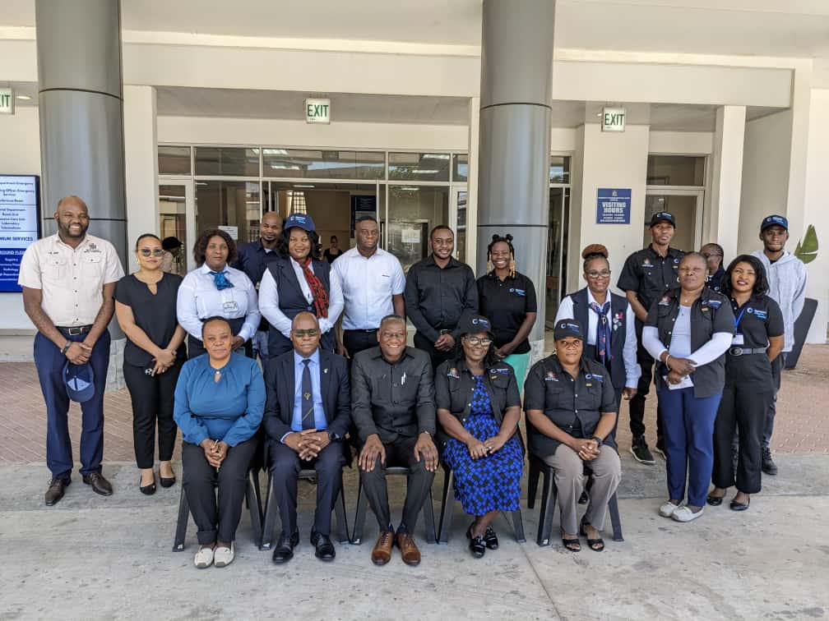

Contents
1.0 Introduction 3
2.0 Keynote Address 4
3.0 Donations and Support 5
4.0 Media Coverage 7
5.0 Theme Significance 8
6.0 Conclusion 10
OTHER PHOTOS 11

1.0 Introduction
World Ostomy Awareness Day 2025 was commemorated in Zambia on 2nd October 2025 at the University Teaching Hospital (UTH) – Adult Wing in Lusaka. This annual global event is dedicated to raising awareness about ostomy care, reducing stigma, and promoting the rights and dignity of ostomates. The chosen theme, “Invisible Disability: Visible Support – The Global Unity of Ostomates,” carried a powerful message: while ostomies are often unseen, the individuals who live with them deserve visible and tangible support from families, communities, health systems, and governments.
The commemoration in Zambia was not only a reflection of solidarity with the global ostomy community but also a platform for national dialogue on strengthening healthcare, access to supplies, and advocacy for policies that support people living with an ostomy.
The event drew a diverse group of key stakeholders who play vital roles in advancing this agenda. The Ministry of Health led the national effort, underscoring government commitment to inclusive healthcare. Corporate sponsors including Shoprite, Wireforce, Radisson Blu Hotel, Continuum, Maxlin Enterprise, Balloon Deco, Zambia Flying Doctors Service, Victoria Hospital and the Fistula Foundation partnered in the initiative, demonstrating the importance of public-private collaboration in healthcare delivery. Continuum Zambia also lent its support, recognizing the intersection between maternal health, surgical interventions, and long-term patient care.
Importantly, the commemoration was not limited to officials and sponsors. It brought together representatives from hospitals across the country, healthcare professionals, caregivers, ostomates themselves, and advocacy groups. This multi-stakeholder presence ensured that voices from all corners of the health and patient ecosystem were heard—from policy makers and service providers to the very individuals whose lived experiences must shape the future of ostomy care in Zambia.
Together, participants reflected on the challenges that ostomates face—such as limited access to supplies, insufficient awareness, and social stigma—as well as the successes achieved so far in building a network of support, advocacy, and improved clinical care.
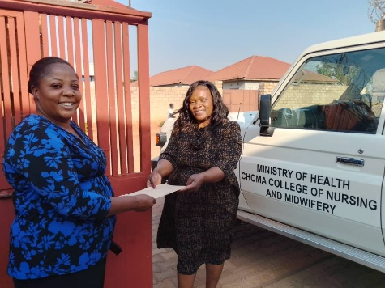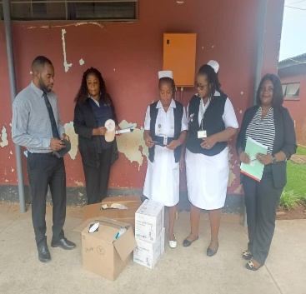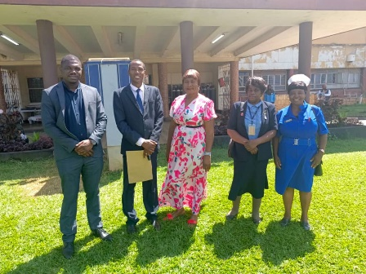
Picture 1 Choma college of nursing, Chilenje Level one hospital & Kitwe Hospital receiving donations

2.0 Keynote Address
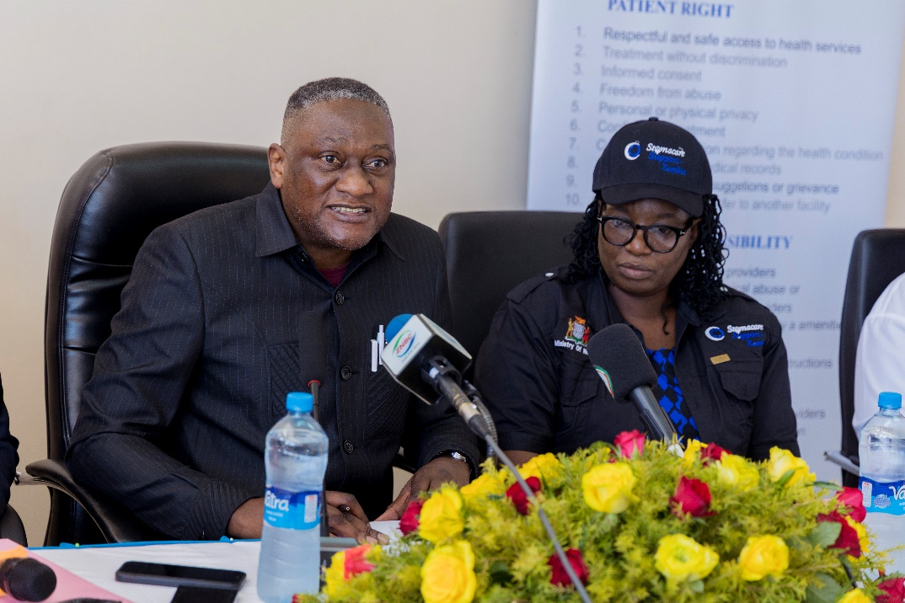

The keynote speech was delivered by Dr. Kennedy Lishimpi, Permanent Secretary for Technical Services at the Ministry of Health, who highlighted the significance of this year’s commemoration for both Zambia and the wider global ostomy community.
Dr. Lishimpi underscored that an ostomy is not merely a medical procedure but a life-saving intervention—a second chance at life for many who face conditions such as colorectal cancer, trauma, congenital malformations, and inflammatory bowel disease. He reminded the gathering that while an ostomy may be an “invisible disability,” it comes with unique challenges that require compassion, systems of care, and societal understanding.
“An ostomy is not a flaw to be hidden; it is a mark of survival that deserves respect,” Dr. Lishimpi declared, drawing applause from participants
He emphasized that true support for ostomates goes beyond the initial surgery and must be anchored in continuous care, reliable supplies, and a stigma-free environment. In his speech, he laid out a comprehensive call to action for Zambia’s healthcare system, partners, and communities:
- Expand post-operative counseling so that every patient leaves the hospital not only with medical instructions, but also with the psychological preparation and confidence to manage life with an ostomy.
- Strengthen review clinics by ensuring they provide holistic follow-up care, addressing not just the stoma site but also skin integrity, nutritional needs, and mental health.
- Guarantee continuity of supplies so that no ostomate is forced to ration, reuse, or improvise critical medical appliances, which can lead to complications and indignity.
- Integrate ostomy care into national health budgets and policies, ensuring that ostomates are fully recognized within Zambia’s healthcare planning framework.
- Tackle stigma head-on by promoting awareness in schools, workplaces, communities, and the media—turning whispers into understanding, myths into facts, and silence into supportive dialogue.
Dr. Lishimpi concluded by reaffirming the government’s commitment to inclusive health systems that leave no one behind. He urged all partners—public, private, and civil society—to work together so that ostomates in Zambia can live full, dignified, and empowered lives.
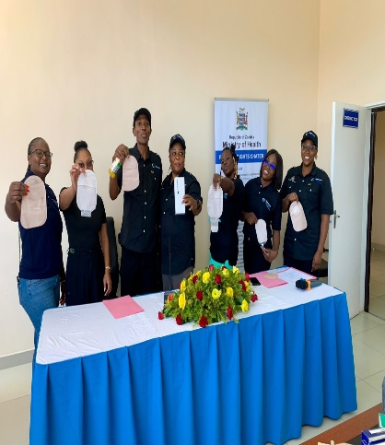
Picture: 2, 3 & 4: officials and health professionals and Stomacare team

3.0 Donations and Support
One of the highlights of the commemoration was the symbolic handover of ostomy supplies to the University Teaching Hospital (UTH) – Adult Wing by Stomacare Support Zambia, a dedicated non-governmental organization working to improve the quality of life for ostomates in the country.
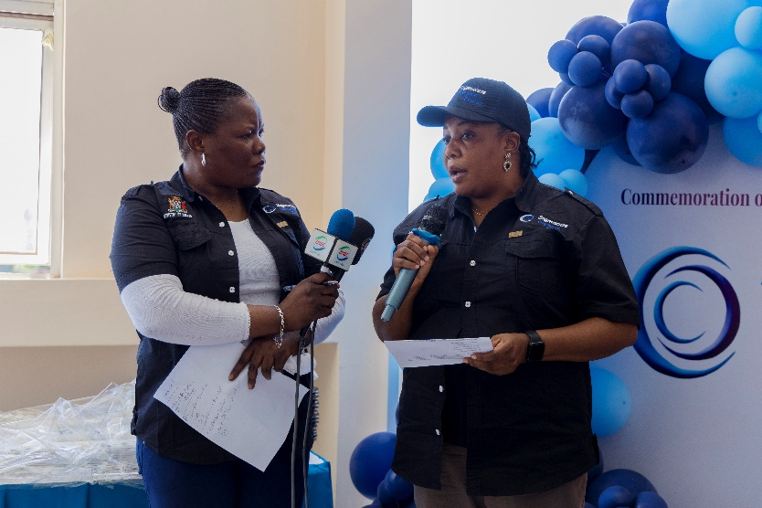
During the event, Stomacare Support Zambia donated 10,776 ostomy bags and accessories, valued at ZMW 4,398,450.00 along with an additional consignment of 10,164 ostomy bags worth ZMW 4,142,590.00 These donations represent not only a substantial financial investment but also a lifeline to hundreds of patients who depend on such supplies for daily living.
Ostomy care appliances are often costly and difficult to access for ordinary families. Without them, ostomates face not only medical complications such as infections, skin irritation, and leakage, but also social and psychological challenges that hinder their participation in school, work, and community life. By providing these supplies, Stomacare Support Zambia is restoring dignity, independence, and hope to many who would otherwise struggle in silence.
In her remarks, the Board chairperson for Stomacare Support Zambia Ms. Kelesia Lungu emphasized that the donations were part of an ongoing effort to ensure that no ostomate in Zambia is left behind. She stressed that such interventions must complement broader healthcare system improvements, including training for health professionals and public awareness campaigns with the help of Jacobs Well Appeal Foundation and European Ostomy Association.
This was not the organization’s first gesture of solidarity. Earlier in the year, Stomacare Support Zambia had already extended similar support to hospitals across the country. Beneficiary institutions included:
- Chilenje General Hospital – 8905 Ostomy Bags
- Choma General Hospital - 5065 Ostomy Bags
- Zambia flying doctors Service - 6000 Ostomy Bags
- Fistula Foundation Zambia - 6000 Ostomy Bags
- Ndola Teaching Hospital - 500 Ostomy Bags
- Kitwe Teaching Hospital -500 Ostomy Bags
- Arthur Davison Children’s Hospital - 500 Ostomy
- Kabwe General Hospital - 500 Ostomy bags
- Kalindawalo General Hospital -
- Sierra Leone Ostomy Association - 2000

- And several other district hospitals and health centers nationwide.
Through these nationwide distributions, Stomacare Support Zambia has established itself as a critical partner in bridging the gap between policy intentions and practical access to ostomy care. Its efforts have lightened the burden on caregivers, improved health outcomes for ostomates, and reinforced the message that living with an ostomy should never mean living without dignity or support.
The donations were received with appreciation by UTH management, who pledged to ensure that the supplies reached those most in need. The gesture also served as a reminder to policymakers and stakeholders that sustainable solutions must include systematic procurement and supply chains, so that donations complement rather than substitute government responsibility.
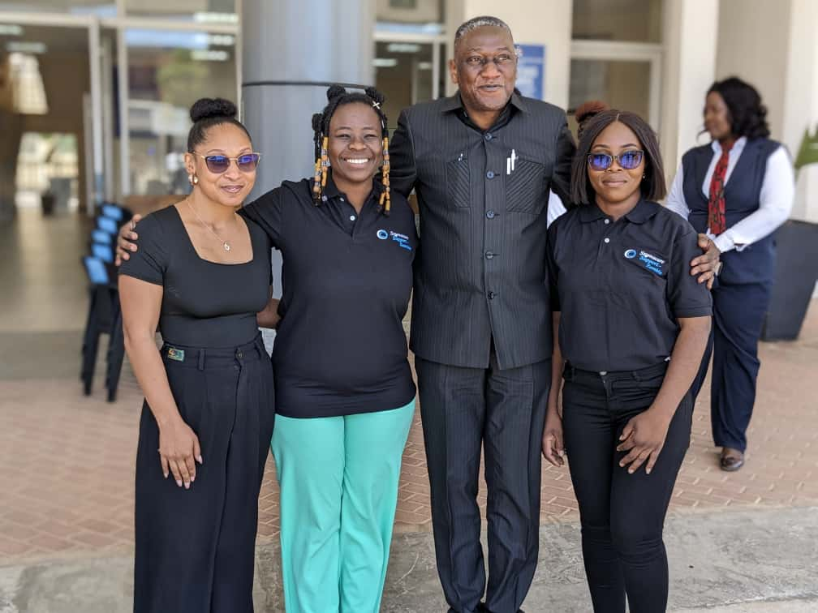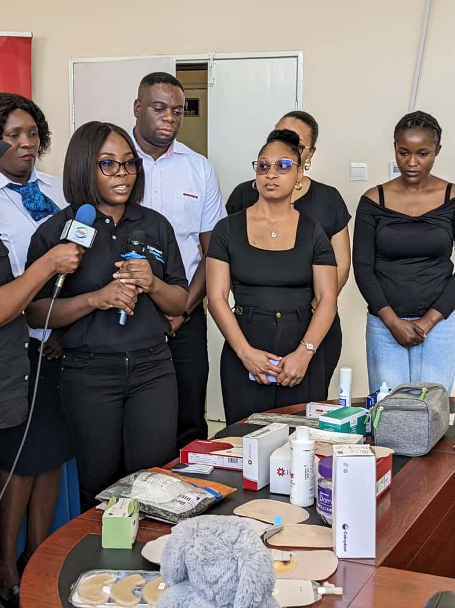
Picture 5: Ostmate posing for a photo with the guest of Honor and explaining the use of kits

4.0 Media Coverage
The commemoration of World Ostomy Awareness Day 2025 received wide publicity across national media platforms, ensuring that the key messages of the day reached a much broader audience beyond those present at the University Teaching Hospital. The coverage played a critical role in raising awareness about ostomy care, reducing stigma, and reinforcing the importance of sustained support for ostomates.
The Zambia Daily Mail, one of the country’s leading newspapers, prominently featured the event. In its report, the newspaper not only highlighted the activities of the day but also underscored the government’s ongoing efforts to expand access to assistive technologies. The article noted the Ministry of Health’s investment in devices that improve the quality of life for persons with disabilities, linking this to the broader commitment to inclusive healthcare services.
The Daily Mail also shone a spotlight on the contribution of Stomacare Support Zambia, which in September 2025 donated ostomy bags and accessories to health facilities prior to the official commemoration. This earlier distribution laid the groundwork for the October event and demonstrated the organization’s consistency in providing life-saving support throughout the year. By recognizing both government action and civil society contributions, the coverage reflected the multi-stakeholder collaboration that lies at the heart of improved healthcare outcomes.
In addition to the Zambia Daily Mail, the event generated attention across radio, social media platforms, and community outlets, where messages around the theme “Invisible Disability: Visible Support – The Global Unity of Ostomates” resonated strongly with the public. Social media in particular amplified the voices of ostomates who shared personal testimonies, thereby helping to normalize conversations around what is often considered a silent or hidden condition.
This extensive media visibility ensured that the commemoration was not just a one-day event but a national awareness campaign, reinforcing the idea that ostomy care is a matter of dignity, public health, and human rights. 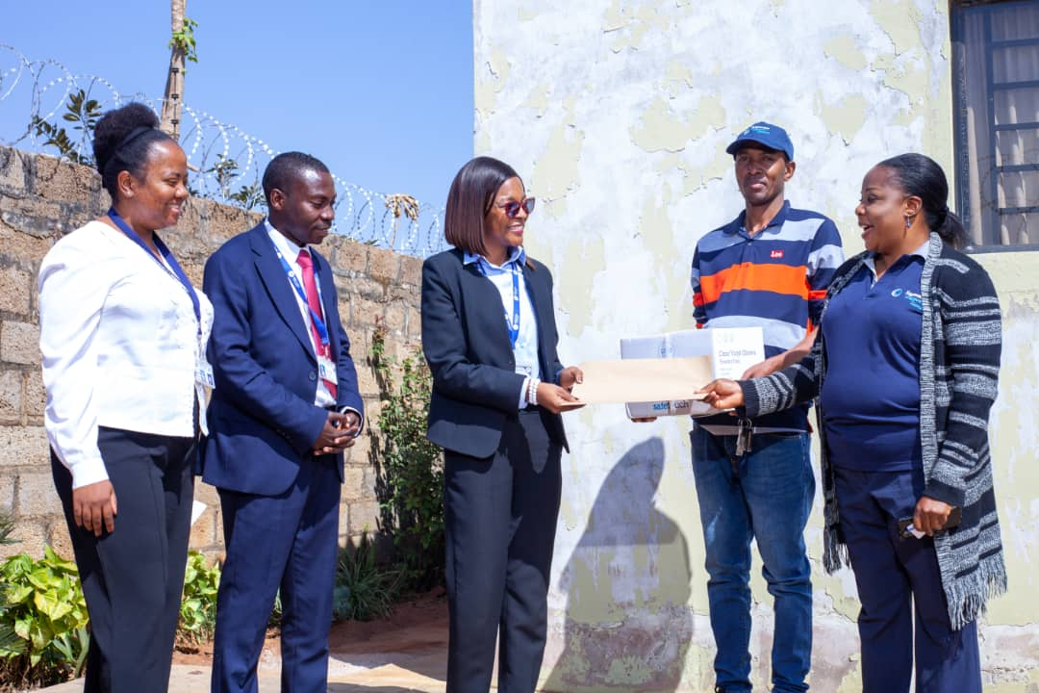
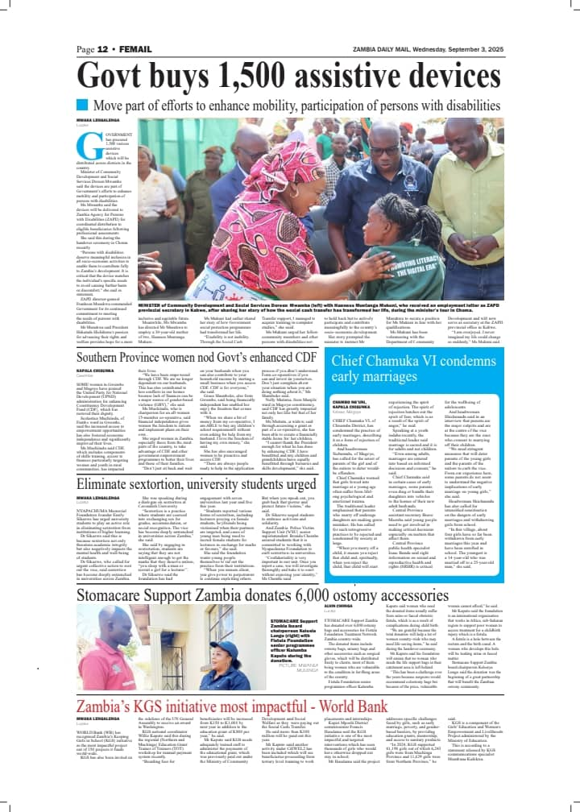
Picture 6:Handing over of ostomy supplies to Zambia Flying Doctors Service team

5.0 Theme Significance
The global theme for 2025, “Invisible Disability: Visible Support – The Global Unity of Ostomates,” carried profound meaning and was woven into every speech, activity, and testimony of the day. It reminded participants that while an ostomy is often physically hidden, the daily challenges and decisions that come with it are very real and demand understanding, compassion, and systemic support.
Throughout the event, speakers, caregivers, and ostomates themselves emphasized several key truths:
- Ostomies are invisible but life-shaping. Many ostomates appear outwardly healthy, yet they live with constant considerations about diet, movement, social participation, and personal confidence. The invisibility of the condition often leads to its neglect in public discourse and policy, but for those affected, it is an ever-present reality.
- Stigma is fueled by silence and misunderstanding. In many communities, a lack of knowledge about ostomies has bred myths, shame, and discrimination. Whispered conversations, avoidance, or insensitive remarks can create feelings of isolation for ostomates. Breaking this silence through open dialogue, education, and awareness campaigns was identified as a powerful tool for changing attitudes.
- Support transforms lives. With proper medical care, reliable supplies, peer networks, and emotional encouragement, ostomates can live full and dignified lives. They can thrive as students, excel in workplaces, nurture families, and contribute meaningfully to society. The presence of caregivers, healthcare professionals, and advocacy groups at the event illustrated that visible, practical support is the key to restoring confidence and independence.
The theme also resonated at a policy level, challenging leaders to create inclusive systems that recognize ostomy care as a core health need. It called for governments, civil society, and communities to make ostomates visible in planning, budgeting, and service delivery.
Perhaps most importantly, the theme spoke to unity. By bringing together government officials, health professionals, corporate sponsors, NGOs, caregivers, and ostomates under one banner, the event demonstrated that dignity is best safeguarded when support is collective and sustained. The voices heard on this day reminded everyone that behind every ostomy is a person with aspirations, talents, and dreams—just like anyone else.
6. Participation and Advocacy
The event drew a wide and diverse audience, reflecting the collaborative spirit needed to advance ostomy care in Zambia. Among the participants were ostomates, whose courage and testimonies formed the heart of the commemoration; healthcare professionals committed to improving clinical care; caregivers who provide daily support at home; corporate sponsors who demonstrated social responsibility; NGOs working in health advocacy; and government officials tasked with shaping inclusive policy.
The day’s program was designed not only to commemorate but also to educate, inspire, and mobilize action. Highlights included:
- Motivational talks from ostomates: Individuals shared powerful personal stories of resilience, recovery, and adaptation, reminding the audience that an ostomy is not the end of a meaningful life but the beginning of a new journey. These testimonies gave a human face to the statistics, breaking down barriers of silence and stigma.
- Advocacy for inclusive policies and stigma-free workplaces: Panel discussions and speeches emphasized the importance of schools, employers, and communities adopting inclusive practices. Calls were made for workplaces to provide facilities such as private restrooms and flexible schedules, while schools were urged to ensure that children with ostomies are supported to learn without fear or shame.
- Commitment from partners: Corporate sponsors, NGOs, and healthcare providers reaffirmed their pledges to continue supporting the procurement and distribution of ostomy supplies. This commitment underscored that while donations are vital, sustainable systems must be built to ensure uninterrupted access to life-saving appliances.
The presence of such a broad coalition of stakeholders reinforced the message that ostomy care is not the responsibility of one sector alone. It is a shared national commitment requiring partnership between the state, the private sector, civil society, and families. By coming together, participants demonstrated the practical meaning of the 2025 theme: making an “invisible disability” visible through collective and compassionate support.

6.0 Conclusion
World Ostomy Commemoration Day 2025 marked a significant milestone in Zambia’s advocacy for ostomates. Beyond commemorating a global day of recognition, the event served as a platform for national dialogue, reaffirming that ostomy care is both a health priority and a human rights issue. By bringing together government, civil society, corporate partners, healthcare providers, and ostomates themselves, the commemoration demonstrated that sustainable change is only possible through unity and collaboration.
The day also signaled a shift in mindset—from treating ostomy as a silent and hidden condition to openly acknowledging it as a reality that demands visibility, compassion, and systemic support. The gathering highlighted that real progress is measured not just by medical interventions, but by whether ostomates feel empowered to live with dignity, confidence, and full participation in society.
The call to action emerging from the event was unambiguous:
- From sympathy to systems – moving beyond one-time gestures of compassion to building long-term structures that guarantee access to care, counseling, and supplies.
- From stigma to support – replacing silence, myths, and discrimination with understanding, encouragement, and inclusion at every level of society.
- From isolated effort to national commitment – transforming scattered initiatives into coordinated national strategies backed by policy, resources, and accountability.
As echoed in this year’s theme, “Invisible Disability: Visible Support – The Global Unity of Ostomates,” Zambia has taken bold steps to ensure that invisible disabilities do not remain overlooked. Instead, they are being brought into the open, where dignity, support, and justice can thrive. Looking ahead, the 2025 commemoration will be remembered not just as a ceremony, but as a turning point—a moment when words were matched with action, partnerships were solidified, and the vision of a Zambia where ostomates are respected, included, and supported became clearer than ever before.
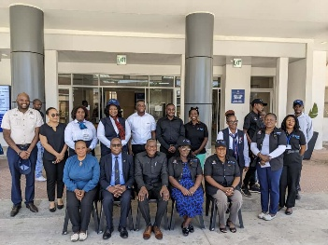
Picture 6: Photos of closing ceremony with the two Hospitals and Ministry of Health team

OTHER PHOTOS
This message was echoed in advocacy posters and social media campaigns shared during the day.
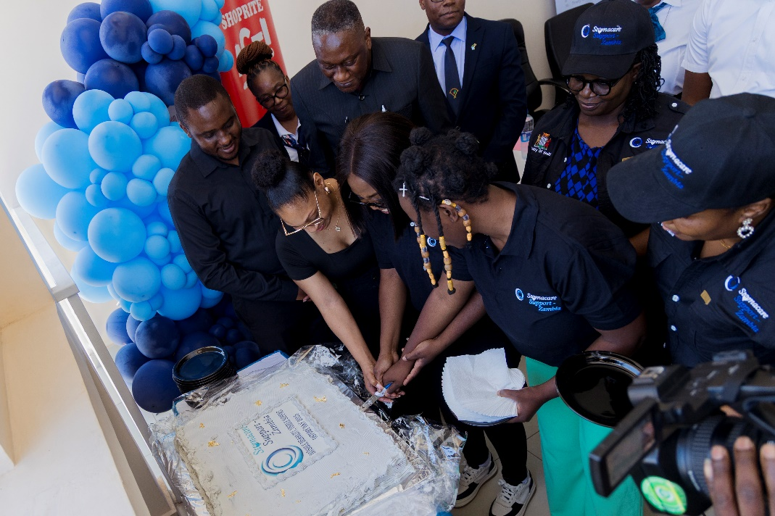
An Ostmate cutting the Cake with the Guest of Honor in commemoration of the Event for 2025

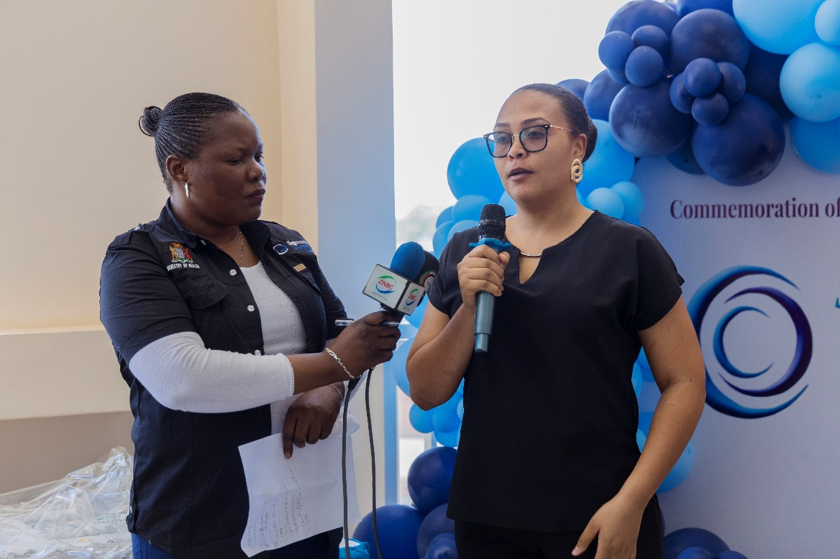

Continuum Zambia Representative

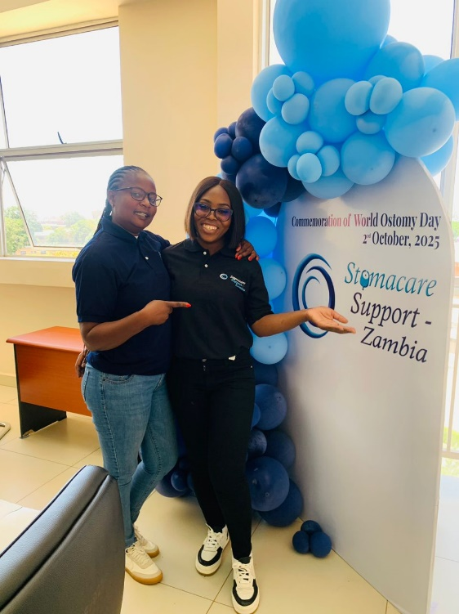
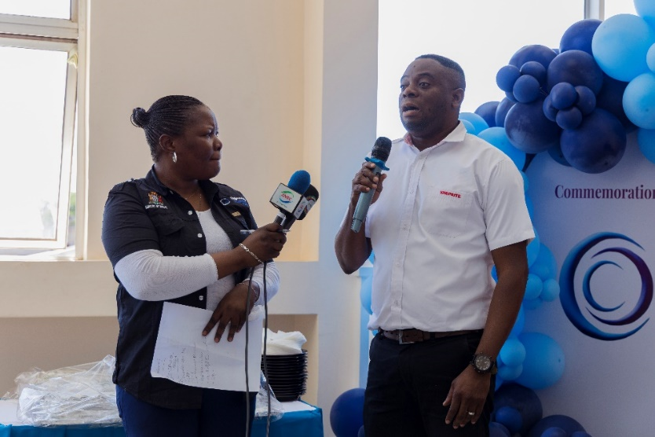
Shoprite Zambia representative

Volunteers after during the event

Report Prepared By:
Kelesia Lungu- Board Chairperson

Plot No 13409 off Joe Chibangu Rd.
Hill View Chalala, Lusaka, Zambia.
Cell: +260967843156
Email: stomacarezambia@gmail.com
Website: stomacaresupportzambia

